# Assignment 4

**Q-1. Create a web page similar to the web page shown below (using frames):**

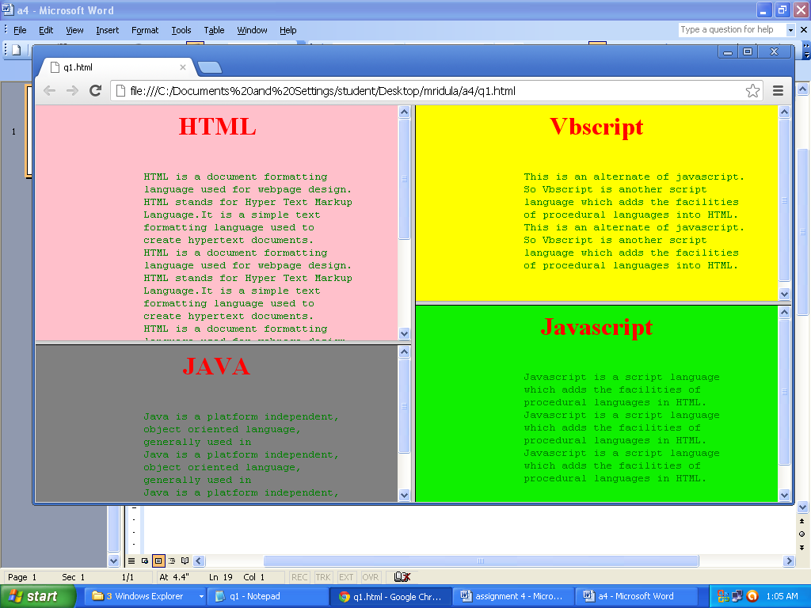

**Q-2. Create a frameset like the one below.**

**You can substitute any content with your own, as long as the “look and feel” of the frames remains the same.**

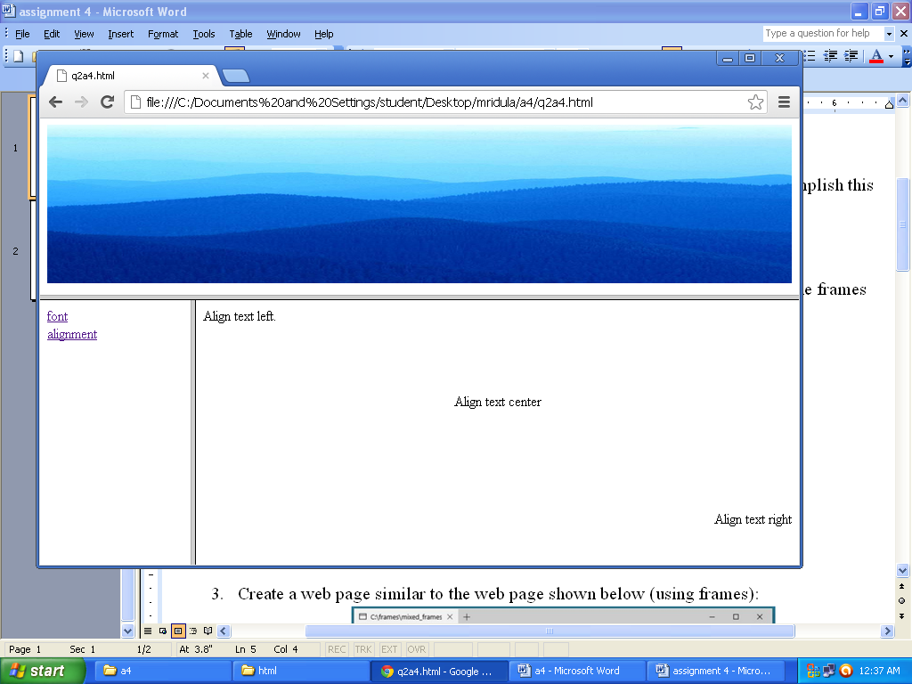

**Q-3. Create a web page similar to the web page shown below (using frames):**

